

CODAPAC PRODUCT REQUIREMENT DOCUMENT (PRD)
UMHackathon 2026
umhackathon@um.edu.my
_______________________________________________

Table of Contents
1. Project Overview 3
2. Background & Business Objective 4
3. Product Purpose 5
4. System Functionalities 5
5. User Stories & Use Cases 7
6. Features Included (Scope Definition) 9
7. Features Not Included (Scope Control) 9
8. Assumptions & Constraints 10
9. Risks & Questions Throughout Development 11

Project Name: Stitch - Google Stich
Version: 2.0

1. Project Overview
- Problem Statement: Building software products is still too dependent on technical coordination, manual ticket handling, and specialist workflows. Non-technical users may know what product they want, but they usually cannot convert that idea into a structured backlog, functioning codebase, tested features, and deployed preview without depending on a full development team. This slows experimentation, raises communication overhead, and prevents many users from turning ideas into working products quickly.
- Target Domain: CodaPac operates in the AI-assisted software delivery and low-code product creation domain. It targets early-stage product ideation, prototype delivery, and iterative software building for web applications. The product sits between project management tools, AI copilots, and deployment platforms by combining all three into one workflow-oriented workspace.
- Proposed Solution Summary: CodaPac provides a project workspace where users create a project, describe what they want in natural language, and let coordinated AI agents manage the planning, coding, testing, and preview deployment flow. `BOSS` creates structured todo cards, `FIXER` implements the requested features in a sandbox, and `TESTEES` writes and runs integration tests before deployment. The user tracks everything through a shared chat and kanban board instead of dealing with repositories, branches, tests, or infrastructure manually.

2. Background & Business Objective
- Background of the Problem: Most software delivery workflows are still fragmented. A stakeholder describes a feature, a manager breaks it down into tasks, developers implement the code, QA validates it, and deployment is handled separately. This process assumes technical knowledge, availability of multiple contributors, and familiarity with engineering tools. For non-technical founders, students, and business operators, this creates a major barrier between an idea and a working prototype.
- Importance of Solving This Issue: If software planning and delivery can be simplified into a single AI-assisted workspace, users can validate product ideas faster, reduce coordination delays, and gain immediate feedback through real deployments. This is especially important for hackathons, rapid prototyping, and early-stage experimentation where speed and clarity matter more than large-team process.
- Strategic Fit / Impact: Codapac aligns with the growing shift toward AI-native development workflows, where planning, coding, testing, and deployment are coordinated through intelligent systems instead of separate disconnected tools. Its impact is in reducing time-to-prototype, lowering the technical barrier for product creation, and creating a repeatable AI-driven delivery loop that can be extended with more advanced programmer and QA behavior over time.

3. Product Purpose

3.1. Main Goal of the System
The main goal of Codapac is to provide an AI-enabled software delivery workspace that turns user intent into a managed implementation pipeline, from idea to tested preview deployment.

3.2. Intended Users (Target Audience)
  - Non-technical founders who want to build product prototypes
  - Students and hackathon participants who need to deliver working demos quickly
  - Product managers who want to convert feature ideas into implementation tasks in a familiar environment

4. System Functionalities
4.1. Description
The system operates as a project-centered AI delivery engine. Users create a project, communicate goals through one shared project chat, and watch work move through a kanban workflow. The system continuously translates user requests into backlog items, implementation work, QA validation, and deployment updates while coordinating execution through GitHub and Vercel.
4.2. Key Functionalities
  - Project Workspace Management: Create and manage live projects with dedicated dashboards for metadata, board state, chat history, and deployment state.
  - AI Planning with BOSS: Interpret user prompts to generate structured task cards, assign them to the appropriate agent roles, and route conversations to the next agent based on board state.
  - Kanban Tracking: Visualize live delivery progress across To Do, In Progress, Done, and Merged with real-time programmer and QA updates in a clear, non-technical view.
  - Programmer Execution with FIXER: Auto-provision GitHub and Vercel projects on demand, run implementation in a sandboxed environment, and merge completed work into main.
  - QA Validation with TESTEES: Execute integration tests in sandbox, reassign failures to FIXER, and trigger preview deployment upon approval.
  - Deployment Visibility: Surface the latest preview URL in the project page and notify users upon successful deployment.
4.3. AI Model & Prompt Design
4.3.1. Model Selection
Codapac currently uses Z.ai’s GLM 5.1 for key agent-driven LLM tasks because the system depends on long-form planning, instruction following, and implementation-oriented responses due to its strong tool calling capability. The model is suitable for backlog generation, reasoning overboard state, generating implementation guidance, and supporting the programmer and QA flows with consistent prompt-based orchestration.
4.3.2. Prompting Strategy
The product uses multi-step agentic prompting rather than a single one-shot prompt. Different prompts are used for planning, routing, programming, and QA. This fits the use case because the system needs different decision behaviors at different stages of work. A product-planning answer should not behave like a coding answer, and a QA answer should be grounded in test validation rather than planning language.
4.3.3. Context & Input Handling
The system handles user input through project-scoped chat context, current board state, and recent project messages. Oversized context is reduced by limiting the recent message window and relevant project card set instead of sending the full project history every time. Practically, the system trims to the most relevant recent items needed for planning or routing. Inputs beyond the effective context window are summarized indirectly through stored project state rather than passed in raw full-history form.
4.3.4. Fallback & Failure Behavior: What does the developed product do when the model returns off-topic or unusable and most importantly hallucinated response? So, is there any mechanism for retrying, a human escalation path or even a graceful error state?

5. User Stories & Use Cases
- User Stories:
  - As a non-technical user, I want to describe my product idea in normal language so the system can plan the work for me.
  - As a project owner, I want to see generated tasks on a board so I understand what is being built and what stage it is in.
  - As a user, I want the system to create repositories and deployments automatically so I do not need to set up engineering infrastructure myself.
  - As a user, I want the correct agent to respond based on the current work stage so the experience feels coherent.
  - As a user, I want to know when my application has been deployed successfully and where I can open it.
- Use Cases (Main Interactions):
  - Planning Flow
The user creates a project and sends a prompt such as “Create a simple todo app.” BOSS interprets the request, creates todo cards with generated descriptions, and places them into the project board.
  - Implementation Flow
The user asks the system to start building. FIXER takes the relevant cards, creates or uses the project repository, writes code in the sandbox, pushes the work to GitHub, and merges the completed work into `main`.
  - QA Flow
Once implementation is done, TESTEES writes integration tests, runs them, and either approves the work or returns it to FIXER if failures are caused by the implementation.
  - Deployment Flow
After successful QA, the project is deployed to Vercel preview. The deployed preview URL is shown in the project page, and a success popup informs the user that the latest preview is ready.
- Use Case Diagram:
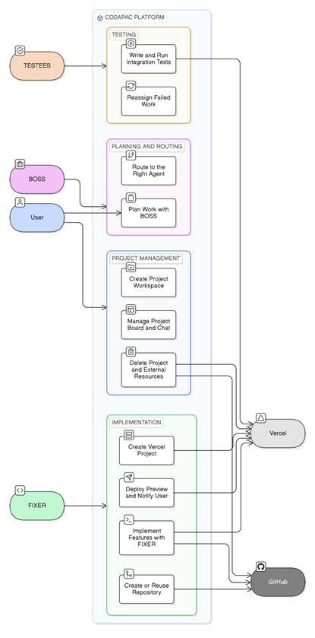

6. Features Included (Scope Definition)
- Project creation and project listing
- Live project dashboard with kanban board
- Project chat with streamed agent responses
- Boss planning and todo generation
- Auto-generated card descriptions
- Agent routing based on project state
- Programmer execution in Vercel sandbox
- Automatic GitHub repository creation when absent
- Automatic Vercel project creation when absent
- QA integration test writing and execution
- Reassignment loop from QA back to fixer on implementation failures
- Preview deployment visibility and success notifications
- Project deletion with external GitHub and Vercel cleanup

7. Features Not Included (Scope Control)
- Production deployment pipeline beyond preview deployment
- Native mobile application generation
- Advanced team permissions and enterprise administration
- Simultaneous multi-user real-time editing workflows
- Full backend architecture generation beyond the current coordinated app-delivery flow
- Billing, subscription, and quota management
- Advanced analytics dashboards for engineering productivity

8. Assumptions & Constraints
- LLM Cost Constraint: Average user sessions may trigger multiple model calls across planning, routing, programmer execution support, and QA behavior. The exact cost depends on prompt length and retries, but the system is designed to keep inference manageable by:
  - Using one shared project chat instead of maintaining multiple separate chat channels
  - Limiting routing context to relevant recent messages and board state
  - Capping retry loops for QA recovery
  - Using structured execution stages instead of sending the entire workspace history for every action
- Technical Constraints:
  - Deployment target is Vercel preview
  - Execution depends on sandbox runtime limits from Vercel
  - GitHub and Vercel APIs must be available for repository and deployment automation
  - Project workflows depend on valid external tokens and team configuration
- Performance Constraints:
  - Planning, coding, QA, and deployment are asynchronous and may take noticeable time
  - Streaming responses are needed to keep users informed during long operations
  - Sandbox jobs may fail or time out, which requires retries and recovery behavior
- User Input: The system is prompt-driven and requires user intent as input before it can act. While the platform automates planning and delivery, it still depends on users to define the product goal, confirm direction, and continue the workflow through the chat and board interactions.

9. Risks & Questions Throughout Development
- Design Similarity: How do we ensure that different projects do not feel too similar in structure, implementation approach, or generated outputs when they are prompted in comparable ways?
- Flow Stability: What should happen when generated code passes initial implementation but produces unstable behavior during QA or after deployment? How much recovery should remain automated before the user must intervene?
- Input Interpretation: What should the platform do when user prompts are vague, conflicting, or too broad for direct execution? Should the system always clarify first, or should it make stronger assumptions and proceed?
- External Dependency Risk: How should the system behave if GitHub, Vercel, or model APIs are degraded or unavailable during project execution?
- Trust and User Understanding: How much technical detail should be shown to non-technical users when failures happen, so the system remains transparent without overwhelming them?

